1KEK -

Functionality
The system transfers payables and receivables to Profit Center Accounting together. The transfer can be made periodically or as often as is required by the user.
The assignment of payables and receivables to various profit centers is basically derived from the offsetting entry line of the FI document to which they belong. If two different products belonging to two different PCA are sold to one customer in a single sales order the FI document has to be adjusted in order to allocate a part of the receivable to both profit centers. This transaction has to be completed before AP and AR can be transferred to PCA. This is the reason why AP and AR are not transferred on line to PCA in a same way as AA, WIP and stock.
It is not possible to make structural changes to them within Profit Center Accounting. If, for example, you assign a new profit center to a material, or change the derivation rules when creating sales orders, these actions do not affect the assignments of documents that have already been posted.

Scenario
Transferring Payables/Receivables to PCA for company code 5200 period 6.

Requirements
The overnight Job of running the transaction F.5D (Calculate Balance Sheet Adjustments) has run successfully.

Menu Path | Accounting → Controlling → Profit Center Accounting → Actual Postings → Period-End Closing → 1KEK - Transferring Payables/Receivables
Transaction Code | 1KEK

1. Double Click on 1KEK - Transferring Payables/Receivables.

Profit Center Accounting: Transfer Payables/Receivables

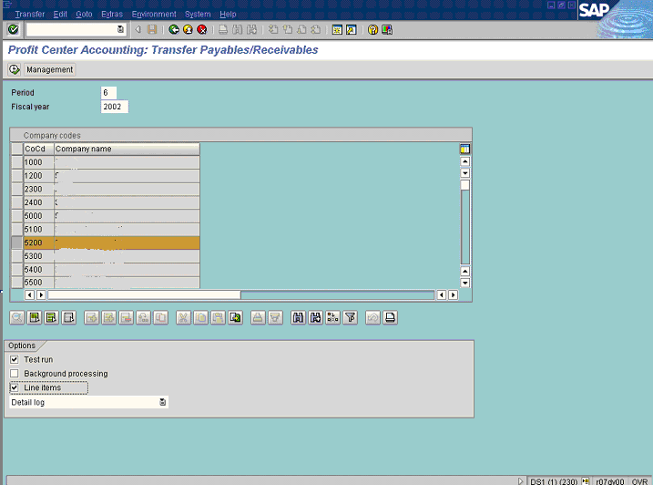
2. Update the following fields:

Field Name | Field Description | Values
Period | Number identifying a fiscal month | Example: 6

3. Select the desired company code by clicking it. For example 5200.
4. Click the <checkbox> Test run .
5. Click <checkbox> Line items .
6. Select Detail log in dropdown .
7. Click Execute Button .

Call up transfer of payables and receivables

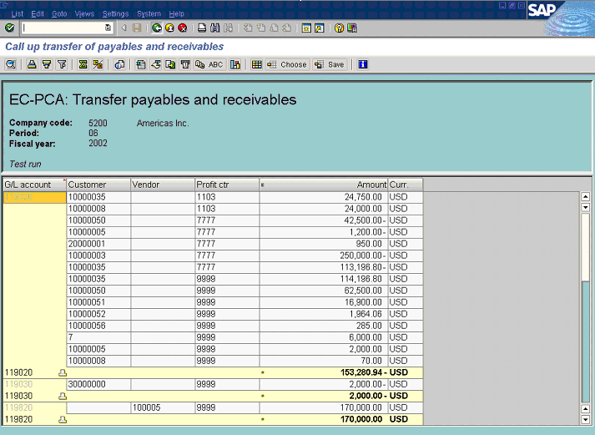
8. Click Back F3 .

Document lines: Display messages

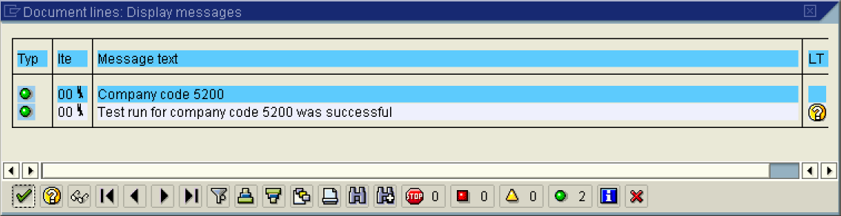

9. Click Enter Button .

Profit Center Accounting: Transfer Payables/Receivables

10. If satisfied by the results Click <checkbox> Test run .
11. Click Execute Button .

Transfer receivables/payables

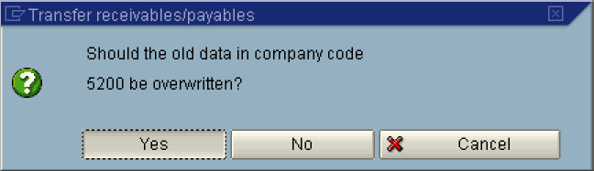
12. Click <tab button> Yes .

Call up transfer of payables and receivables

13. Click Back .

Document lines: Display messages

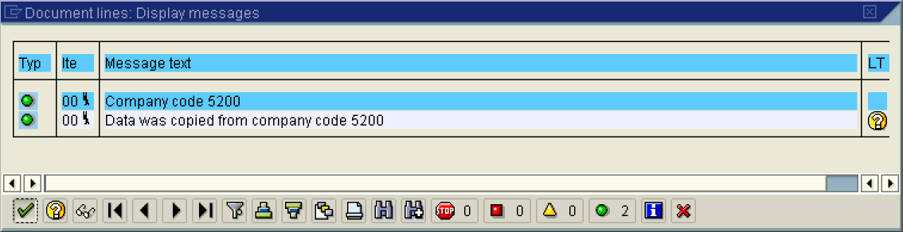

14. Click Copy Enter Button .

15. The message bar displays “data was copied from company code 5200”

